Thursday 15th Feb detailed dev log

ROTATIONAL GRAVITY

Oh boy. So. Let’s create a loop to run around in.

Doesn’t exist in Unity? We’ll make one in blender!

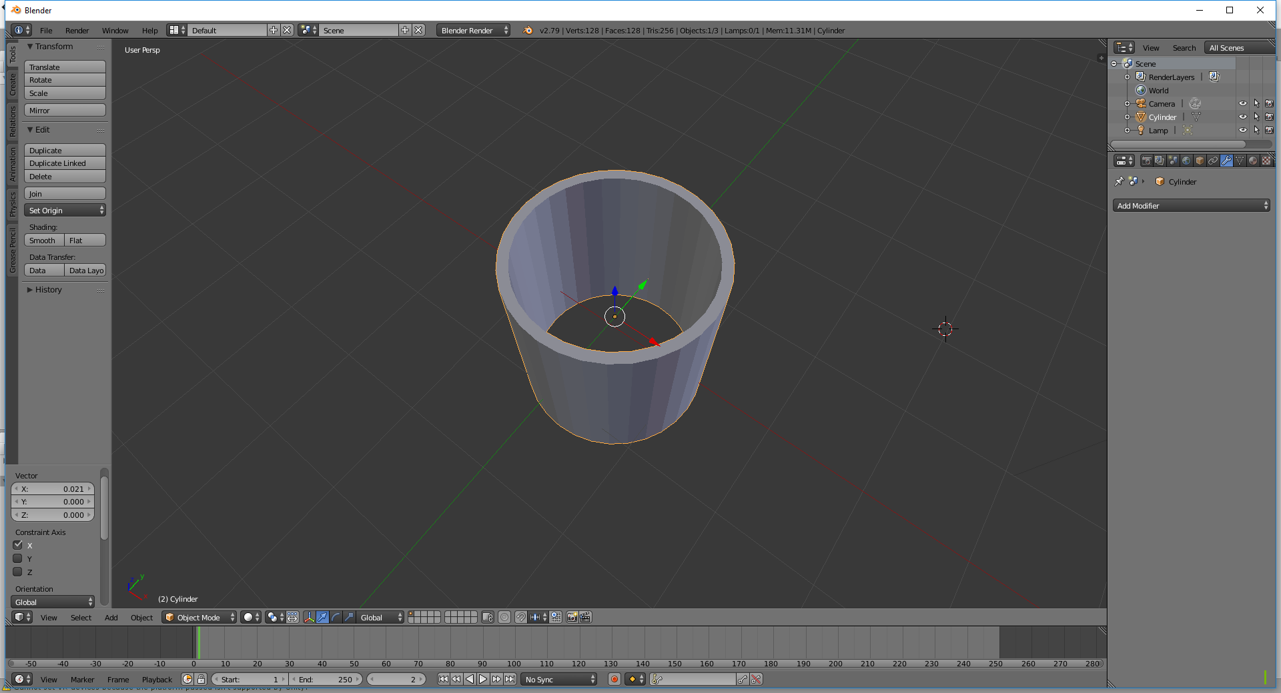

Import this and we have a cylinder

THEN SPEND ALL DAY TRYING TO GET RAYCASTS TO WORK OMG